MapReduce Students Performance in Exams- Coursework 3


Aikaterini Christopoulou s-ac290387
Colab link: https://colab.research.google.com/drive/16X5TjhCFPMCCmRcq4gCuUVxWkkx_TXKr?usp=sharing

Πίνακας περιεχομένων
1. Introduction 3
2. Dataset 3
3. Data preprocessing 3
4. Stratified train-test split 3
5. Map Reduce 5
6. Workers 6
7. results 7
8. Reflection 10
9. future improvements 10

Introduction
This coursework is based on the dataset Kaggle “Students Performance in Exams” and its purpose was to analyze their overall performance. This was analyzed through creation of a new variable named “average score” . Stratified sampling was applied, and class distributions were counted through a MapReduce approach.

Dataset
This data set contains a total of 1000 instances and 8 variables. None of the variables were directly used for this analysis, but 3 variables contributed to the creation of the new variable named average score, which is the mean of reading score, writing score, and math score. No missing values were found as well.

Data preprocessing
Apart from checking for missing values in order to transform the data into a classification task a new variable was created named :
Average score=(math score+ reading score + writing score)/3
This variable indicated the overall performance, was divided into categories to transform it into a classification worthy analysis, through categorization. The approach was based on real-life examples (such as the Greek university grading system) for the classification to be distinct and understood. Other approaches could be implemented as well.
- A (≥ 85)
- B (65–84)
- C (50–64)
- Fail (< 50)

Stratified train-test split
Stratification ensured that class distribution remained the same across train-test splits. For this analysis, stratification is utterly important because it makes MapReduce results meaningful and reliable. MapReduce counts the frequency of each class(A ,B, C, Fail) , so it depends entirely on the distribution of the classes in the train split. Without it the results become biased and they don’t depict the actual distribution of the classes throughout the data set. In conclusion , Stratified split is mandatory because it preserves the original class distribution of the dataset, meaning that the aggregated counts reflect the original dataset analogy. A typical machine learning approach was to follow the (80/20) train-test split that usually gives sufficient results, but in this case, a data-driven approach was followed, as it provided high accuracy and good performance. The approach that was followed in this case was testing different train-test combinations and finding the most optimal for this case through a decision tree model that tested the multiple configurations. A decision tree is highly sensitive to data distribution, and its results are easy to interpret. Entropy that was used as the criterion of splitting is a good measure, and it was chosen because it creates high-quality splits that minimize uncertainty. The (60/40) split produced the overall best results, and it had great predicting scores, without this being an overfitting choice! (This was measured with the overfit gap. It produced accurate results in the train and test parts, proving it a valid solution.
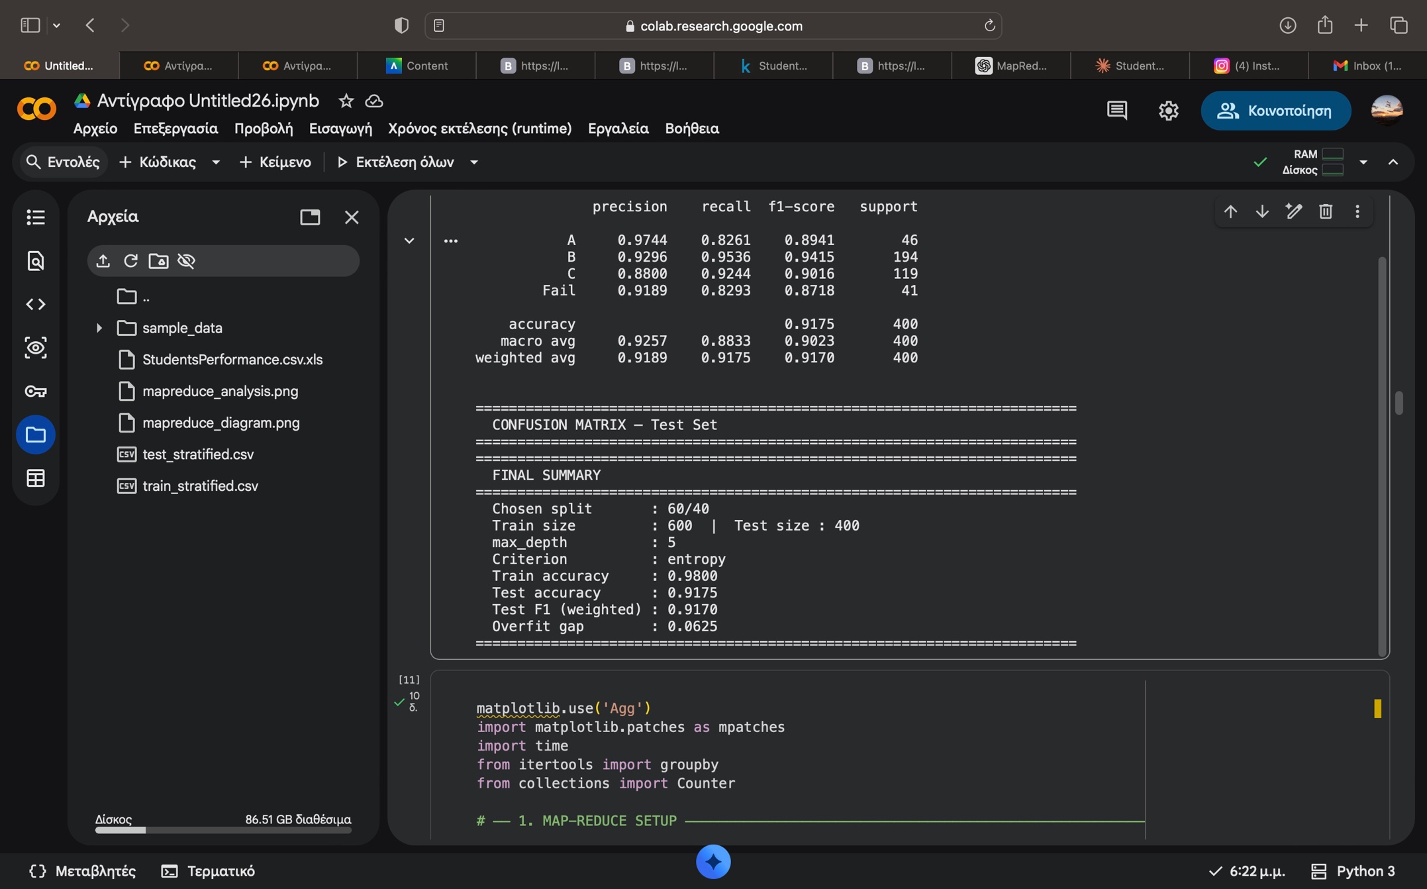
The confusion matrix highlighted the true positive results, validating that choice.

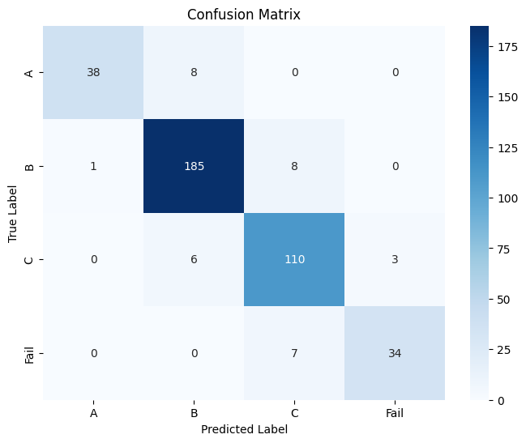

Map Reduce
Map reduce is a data-processing model that is used to handle large datasets by splitting work across multiple workers. In this dataset the class (A,B,C,Fail) were counted using that model. First, the user inputs the data. Then, the data are parted into chunks (as many chunks as the number of workers).After that the actual map-reducing process begins with the first step being the worker that maps the data into (grade,1), after that they are grouped per key (A,B,C,Fail) and then sorted (gathering all the identical keys together) and finally reduced- counted all by key. Even in a small dataset like this one it is beneficial as :
- It enables parallel computation (using multiple workers)
- Processing is clear and divided to MapReduce Stages
- Its an efficient method to complete aggregation tasks(just like dividing students progress)
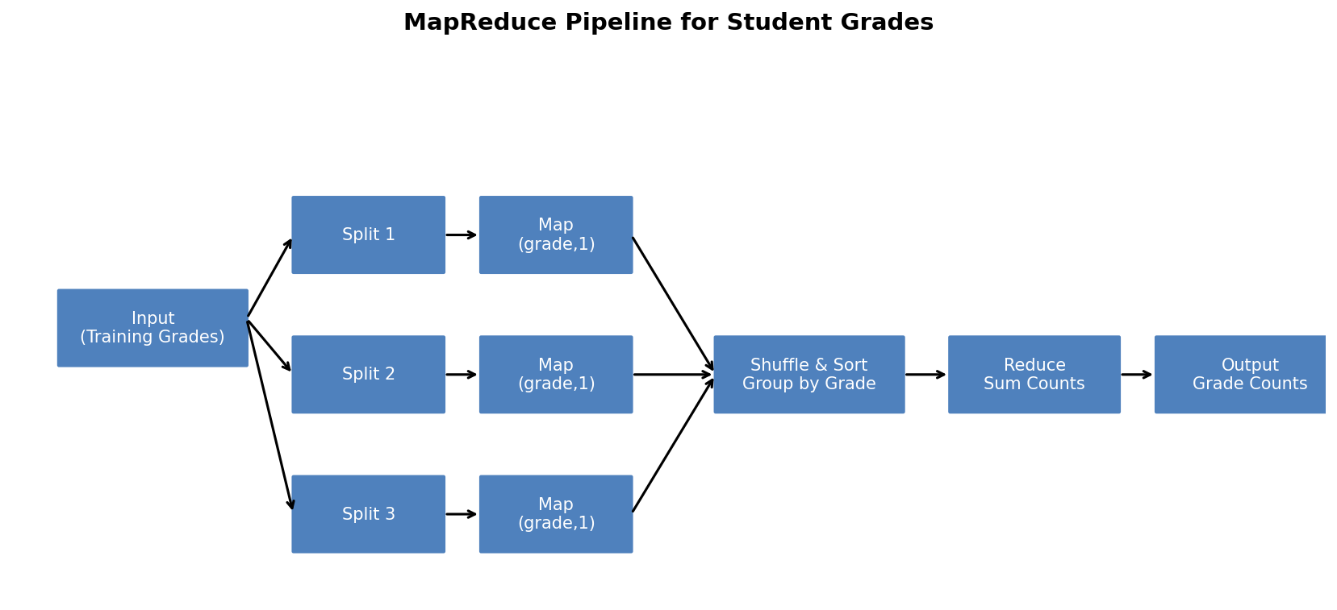

Workers
For this dataset, a small number of workers should be used as it is, by size, a small dataset. Using one worker is not beneficial as it removes all benefits of parallelism, but using too many workers makes the marginal benefit smaller, and the work is not distributed in a balanced way making it insufficient. A good number of workers is one with balanced chunks, well distributed workload , parallel efficiency and low overhead. This is validated even by economic theory! For selecting an optimal number of workers I used gaps as a criterion (IF GAP=0) in order to ensure that chunks-workload are balanced, and also elbow method that calculates the drop ratio of improvement which stops at 3 workers, as the results from 1-2 workers range at 50%(improvement ) while at 2-3 workers range at 33,3%, meaning any additional worker does not benefit more than the previous one. In conclusion, the optimal number of workers are 3. Finally , it should be mentioned that workers do not influence the map reduce algorythm result but the runtime,(making efficient computations).
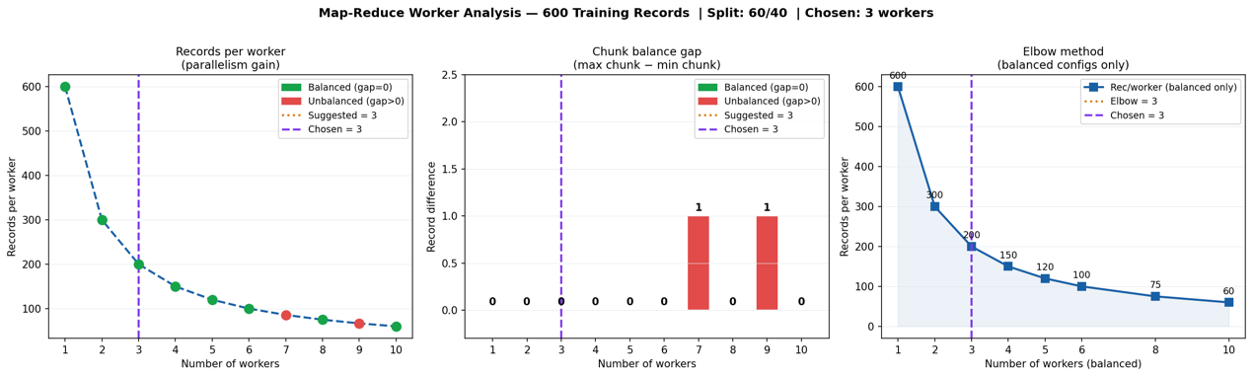
Those images display that parallelism gain diminishes after the 3rd worker , that the workload is balanced and based on the records each worker handles what is an efficient chunk by size (using the elbow method).

results

The grade distribution was the following after the analysis:
A:70
B:291
C: 177
Fail: 62
This sums up to 600,meaning the MapReduce run correctly and categorized all training samples per key. The decision tree proved that (60/40) split learnt well 98% accurately and generalized well 92% accurately -without much generalization ,making this choice valid.
- Class performance analysis:
Best performing class that had high recall -almost all b students were correctly identified and had more training examples that throughout them the model learnt well. C,A were also good with c having good balance and a high precision but lower recall. Fail was the worst predicting class but it was expected due to low training instances-harder for machine learning.
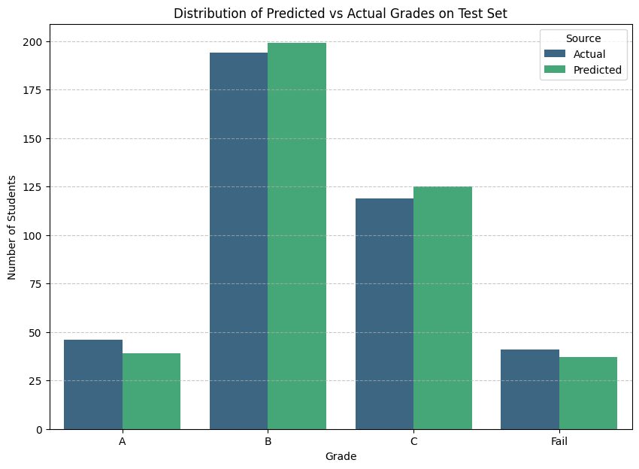
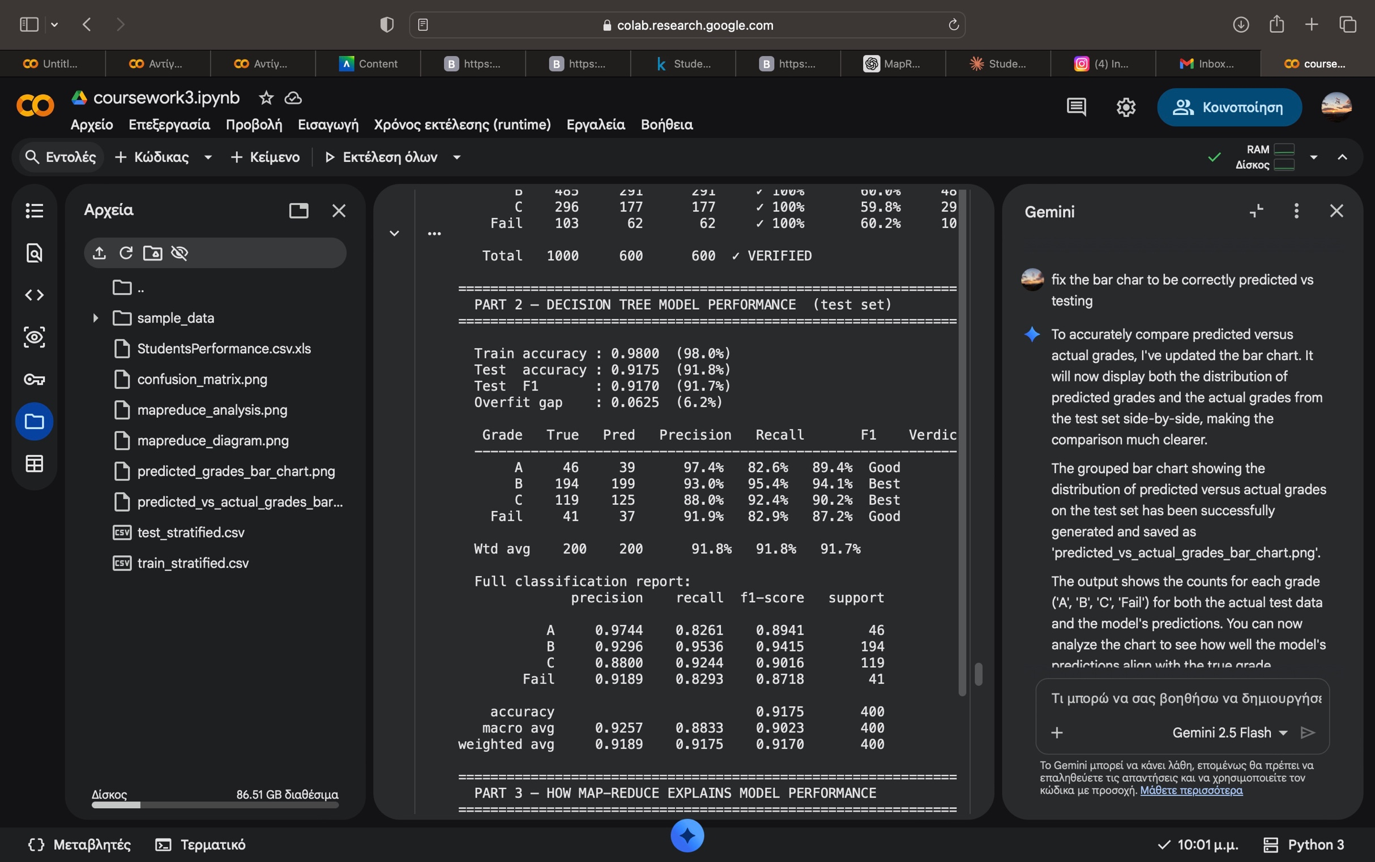
- MapReduce -decision tree model connection
==========================================================
PART 3 — HOW MAP-REDUCE EXPLAINS MODEL PERFORMANCE
- ========================================================================

- Grade MR Count % Train Model F1 Connection
- ------------------------------------------------------------------------
- A 70 11.7% 89.4% Well represented → solid performance
- B 291 48.5% 94.1% Most training examples → best recall (95.4%)
- C 177 29.5% 90.2% Well represented → solid performance
- Fail 62 10.3% 87.2% Fewest in MR relative to F1 → worst recall (82.9%)

- ========================================================================
The relationship between the decision tree model and f1 -more data better performance. The best performing model is B, which appears the most times. A,Fail appear less times so their predicting ability is slightly worst- worsen recall
- FINAL SUMMARY
- ========================================================================

- Map-Reduce
- Workers : 3 (perfectly balanced, gap = 0)
- Training records : 600 (test set of 400 excluded)
- Result : {'A': 70, 'B': 291, 'C': 177, 'Fail': 62}
- Verified : 600 / 600 ✓

- Decision Tree (criterion=entropy, max_depth=5)
- Train accuracy : 0.9800
- Test accuracy : 0.9175
- Test F1 : 0.9170
- Overfit gap : 0.0625
- Best class : B (most training examples in MR: 291)
- Worst class : Fail (fewest training examples in MR: 62)

- Most data → best F1 (94.1%)
Final result: this prediction model has a high training and testing ability without being overfitting. The results are influenced by class distribution(highlighted by map reduce) , more instances meaning higher precision and recall-more accurate prediction. Map reduce counts directly and its results explain the decision tree outcome.

Reflection
This was a data aggregation analysis to analyze student performance. The decision tree model outcomes validated why the (60/40) split was a valid data influenced choice. MapReduce algorythm highlighted the importance of class distribution and predictive model performance. Also, it showcased how parallel processing works in large datasets- choosing 3 as the optimal number of workers, showcasing how optimal distribution in workload works and efficiency.

future improvements
- use more accurately predicting models (such as random forests)
- tune hyperparameters
- real distribution in map reduce(real life models)
- class imbalance handling

